**sdg_index_score and goal_1_score by goal_1_score**

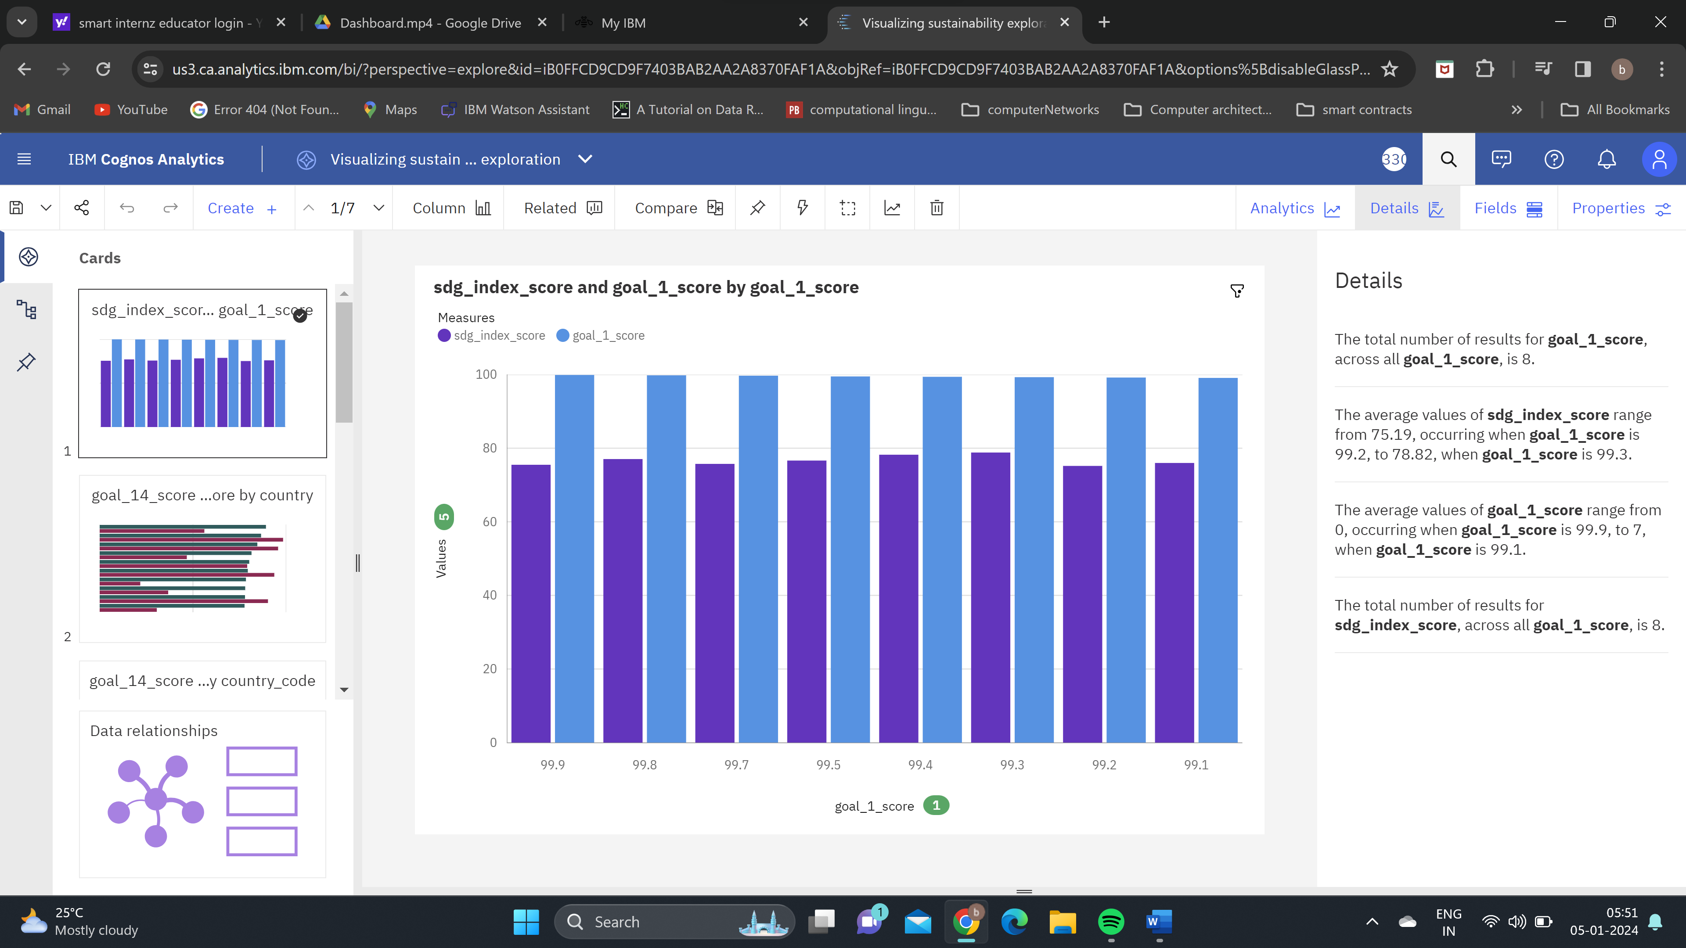

**goal_14_score and goal_4_score by country**

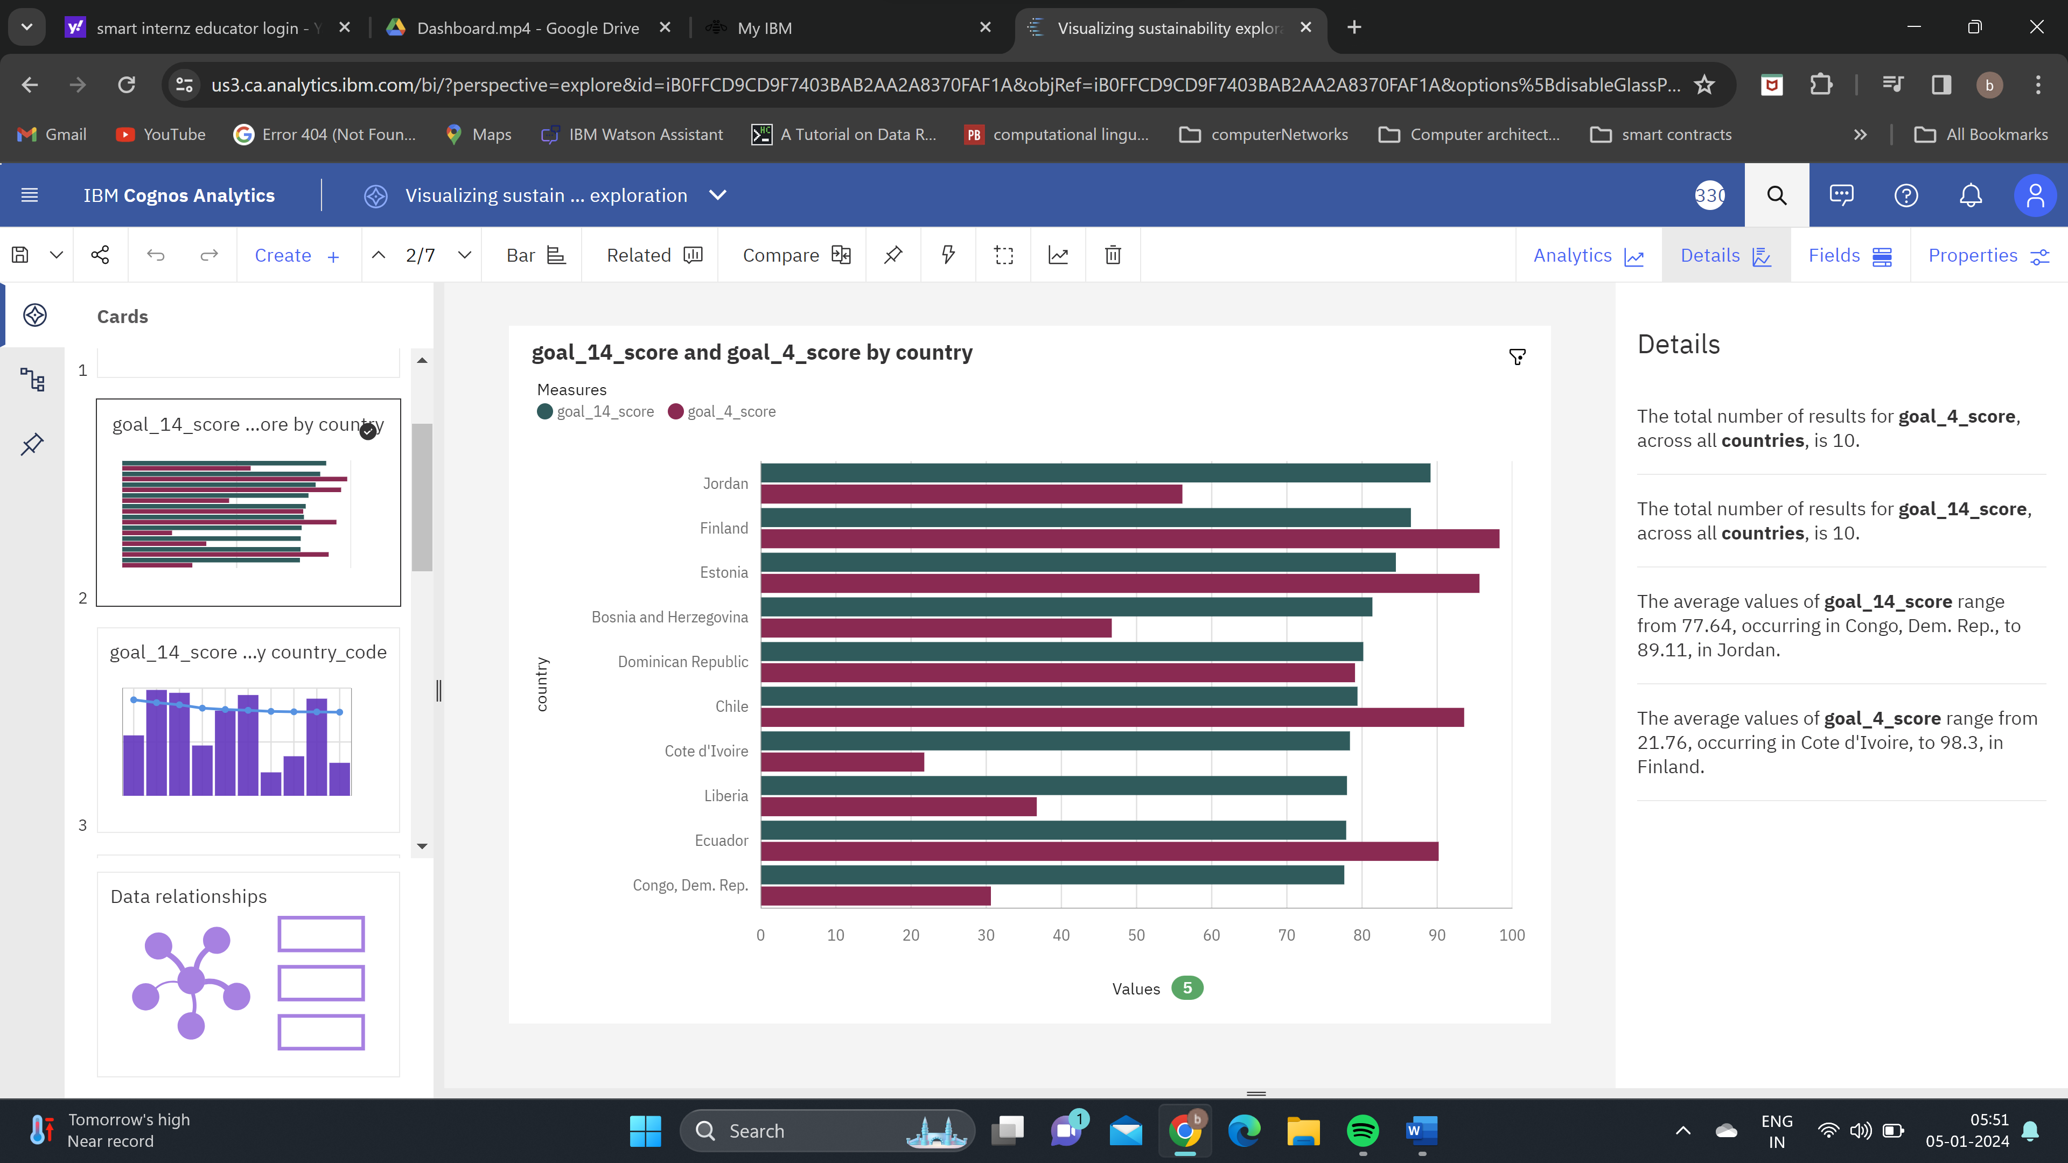

**goal_14_score and goal_4_score by country_code**

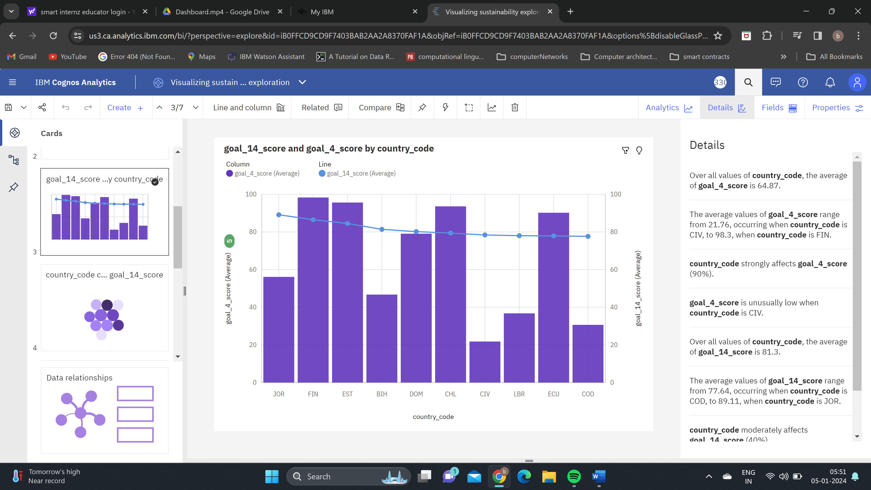

**country_code colored by goal_17_score sized by goal_14_score**

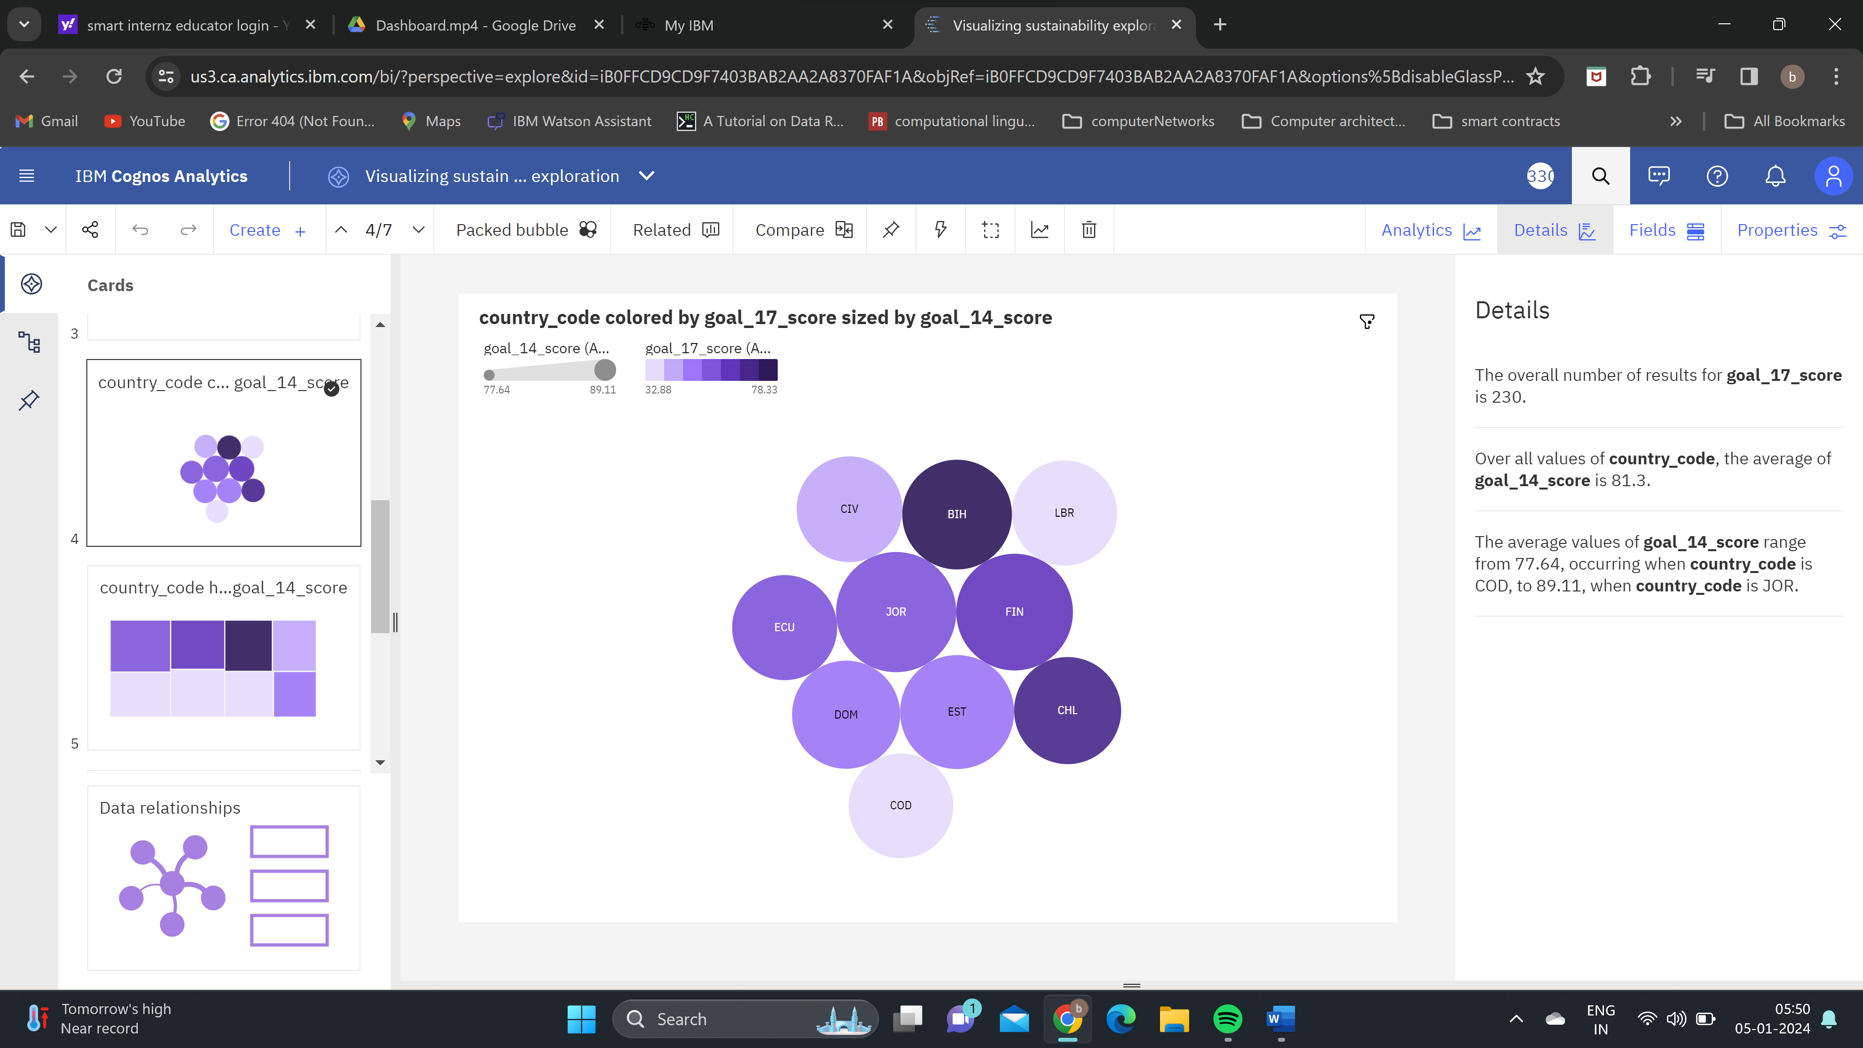

**country_code hierarchy colored by goal_10_score and sized by goal_14_score**

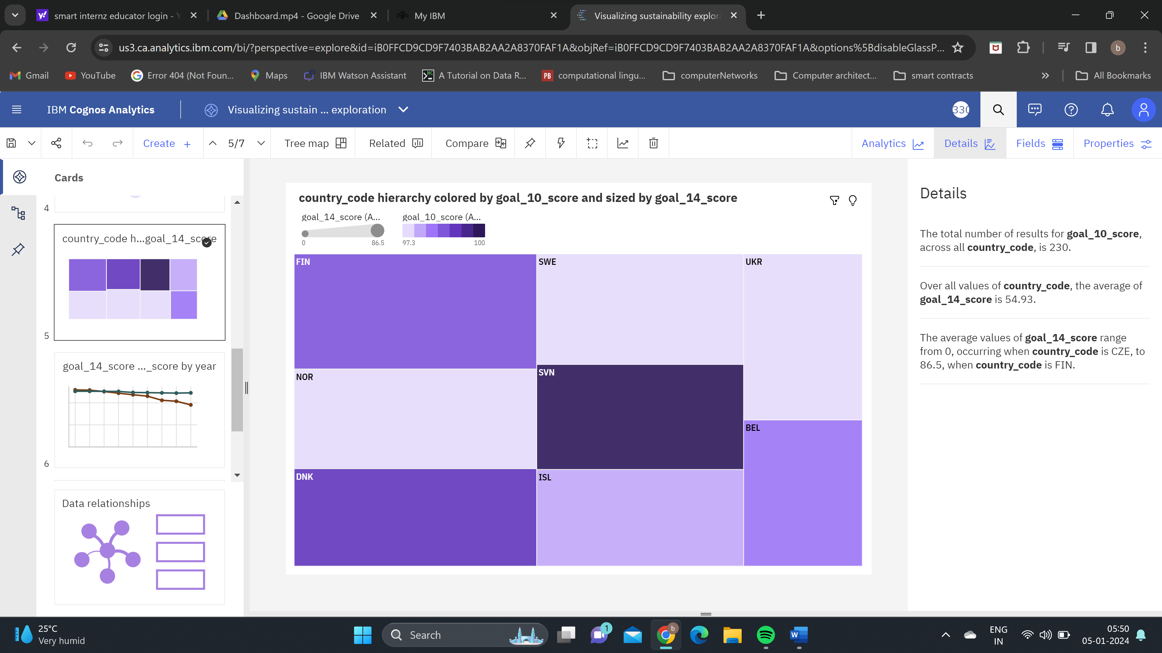

**goal_14_score and goal_9_score by year**

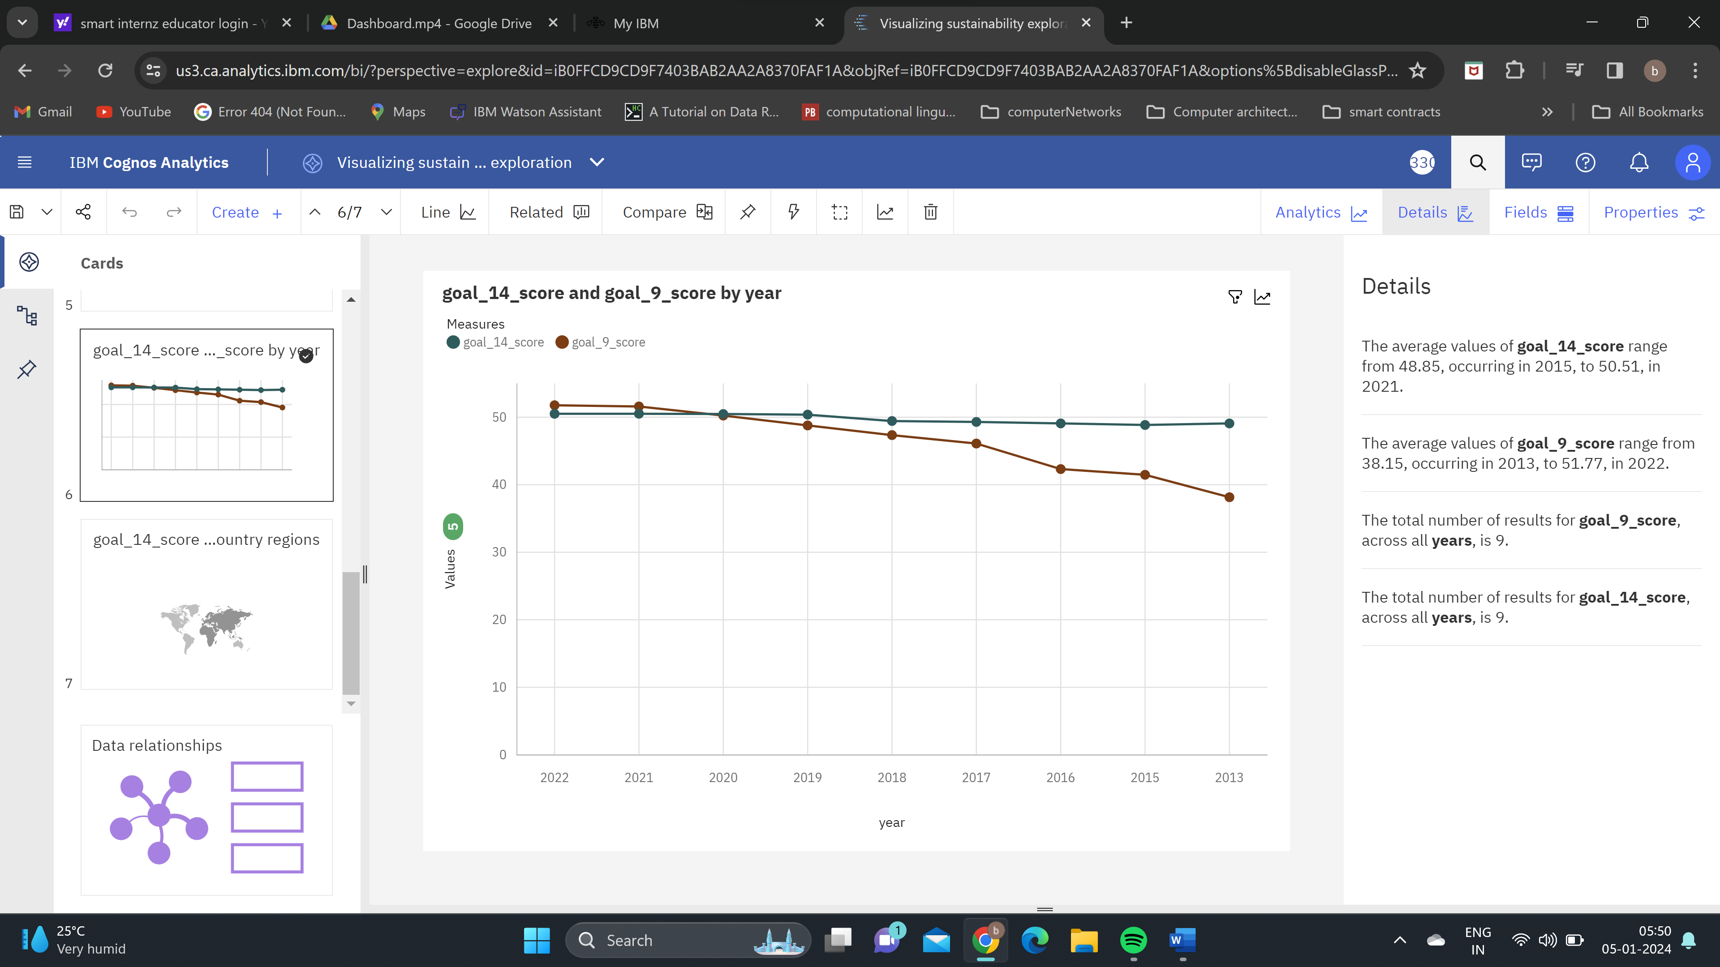

**goal_14_score and goal_15_score for country regions**

